**LAB SHEET 3**

Aadithyan Raju - AM.EN.U4CSE21301

1. Given an array of size **N**. Find the length of the subarray having maximum sum.

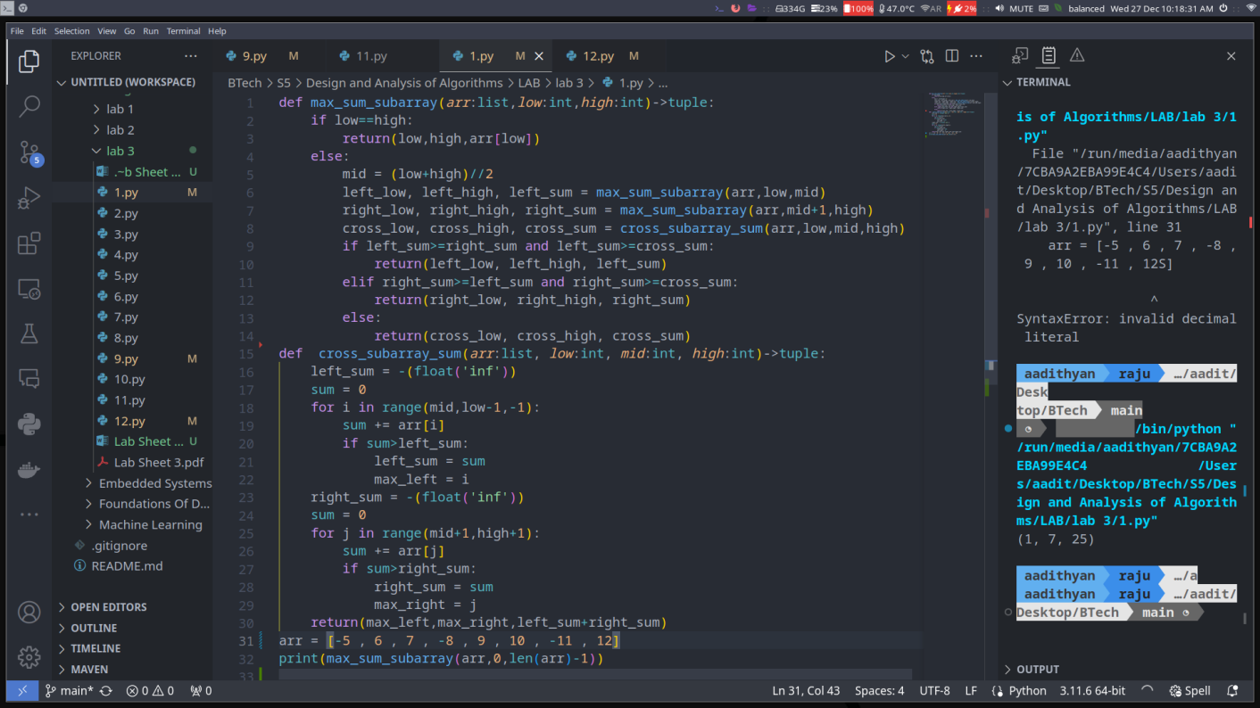

1. Given an array and a number k, find the largest sum of contiguous array in the modified array which is formed by repeating the given array k times.

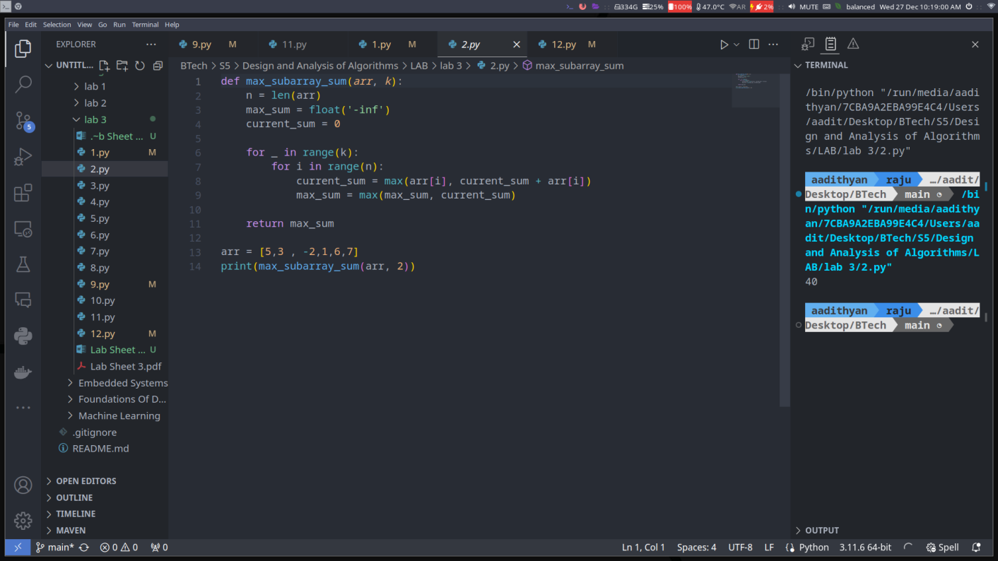

1. Given an array of non-negative integers of length N and an integer K. Partition the given array into two subsets of length K and N – K so that the difference between the sum of both subsets is maximum.

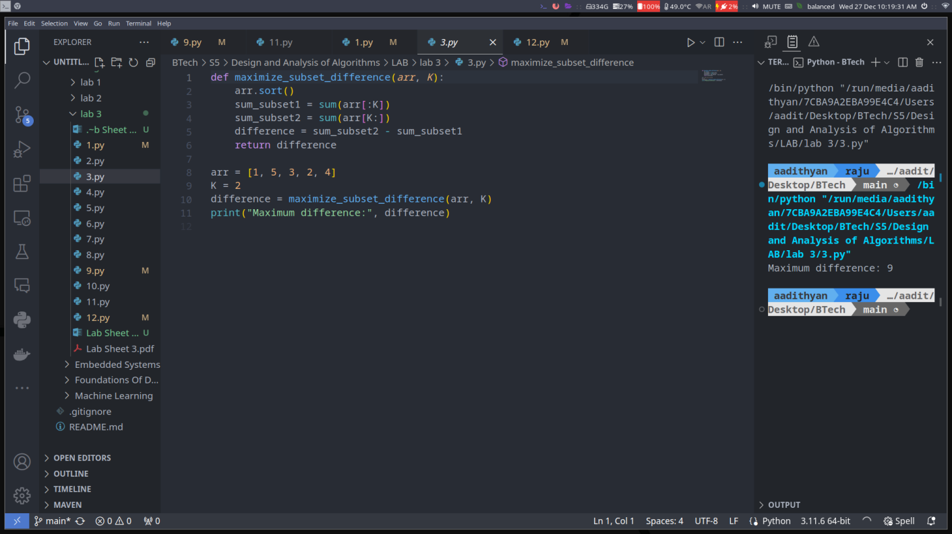

1. Given a string **S** of distinct character of size **N** and their corresponding frequency **f[ ]** i.e. character **S[i]** has **f[i]** frequency. Your task is to build the Huffman tree print all the huffman codes in preorder traversal of the tree.

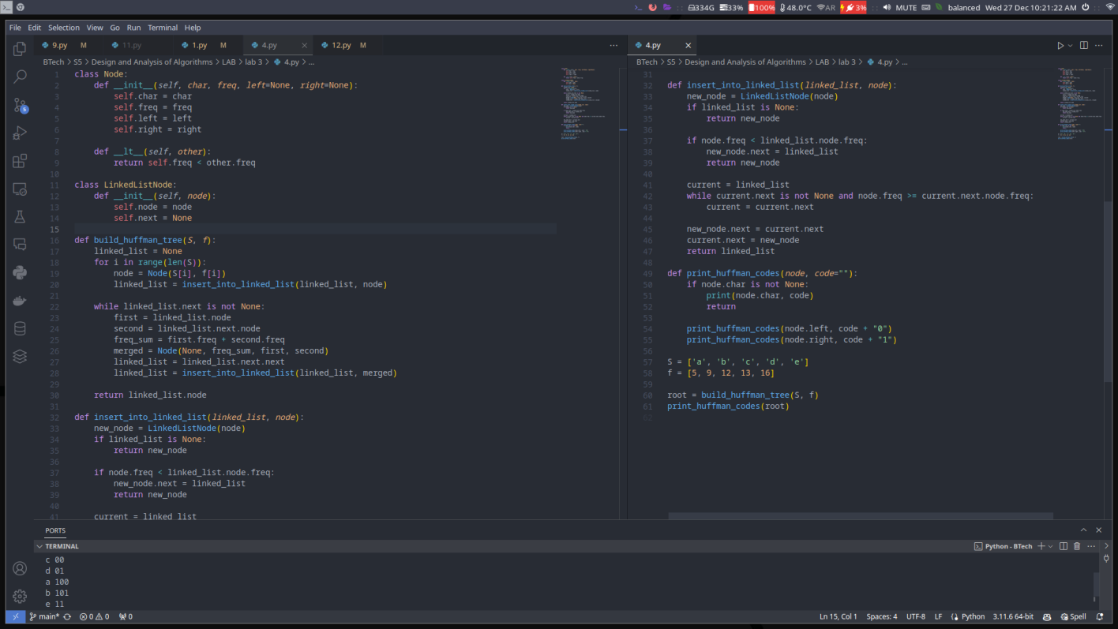

1. Given a list of coins of distinct denominations and total amount of money. Find the minimum number of coins required to make up that amount. If that money cannot be made up using given coins you may assume that there are infinite numbers of coins of each type.

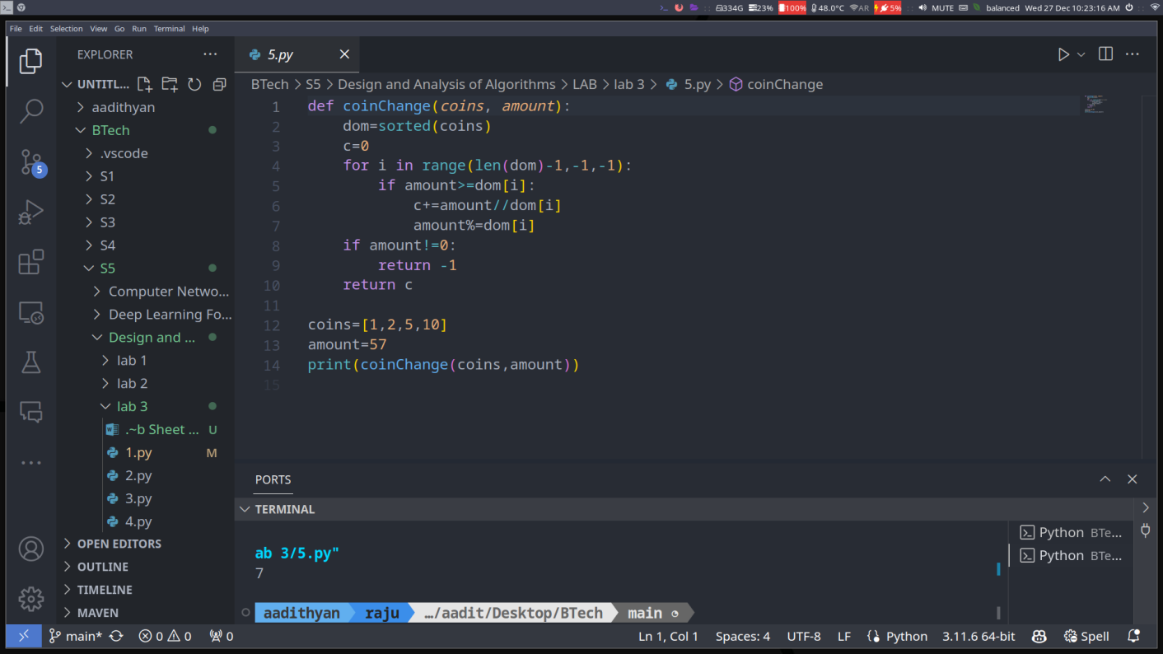

1. Given a set of **N** items, each with a weight and a value, represented by the array **w** and **val** respectively. Also, a knapsack with weight limit **W**. The task is to fill the knapsack in such a way that we can get the maximum profit. Return the maximum profit.

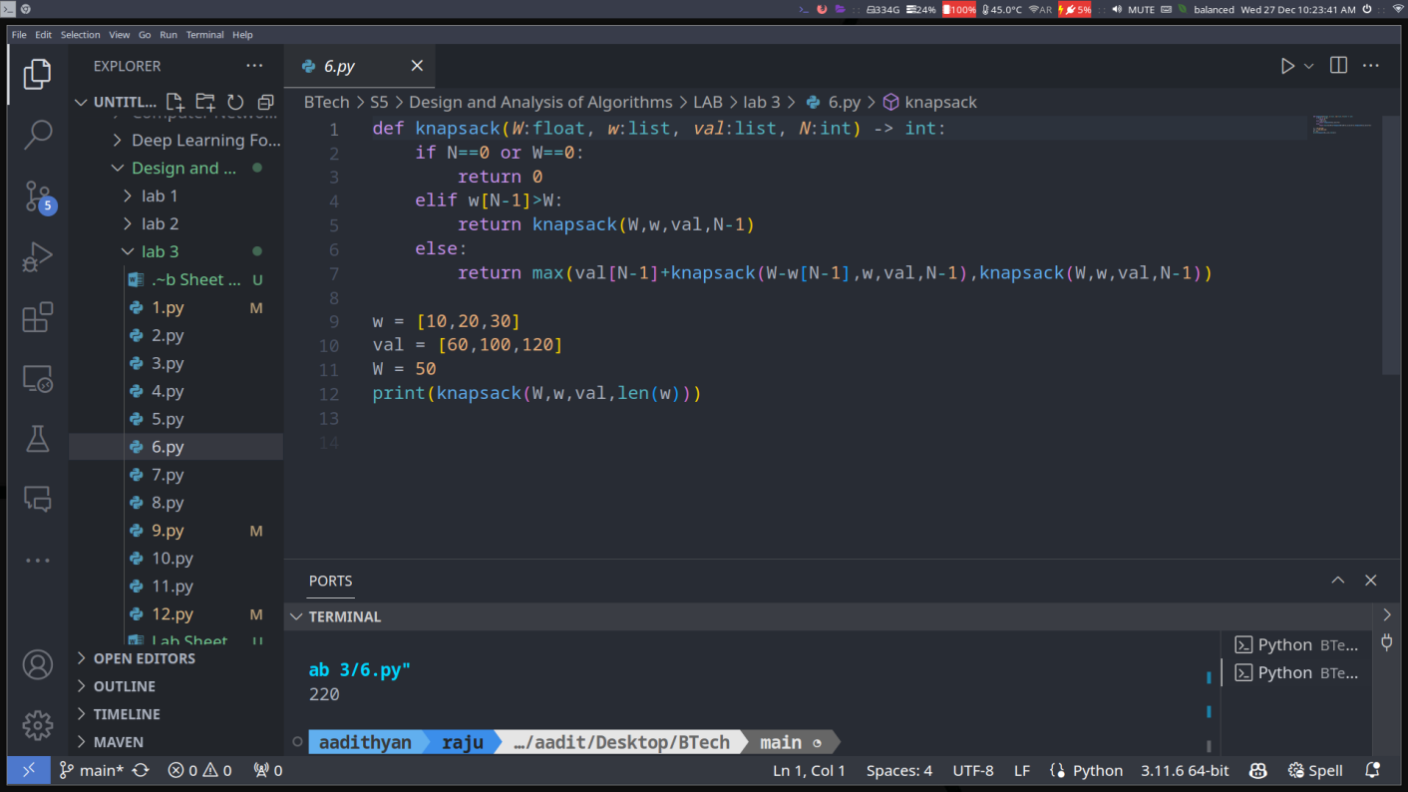

1. Given n integers. The task is to minimize the sum of multiplication of all the numbers by taking two adjacent numbers at a time and putting back their sum % 100 till a number is left.

**Input :** 40 60 20

**Output :** 2400

1st possibility: Take 40 and 60, so multiplication=2400 and put back (60+40) % 100 = 0, making it 0, 20.

Multiplying 0 and 20 we get 0 so

multiplication = 2400+0 = 2400. Put back (0+20)%100 = 20.

2nd possibility: take 60 and 20, so 60*20 = 1200, put back (60+20)%100 = 80, making it [40, 80] multiply 40*80 to get 3200, so multiplication

sum = 1200+3200 = 4400. Put back (40+80)%100 = 20

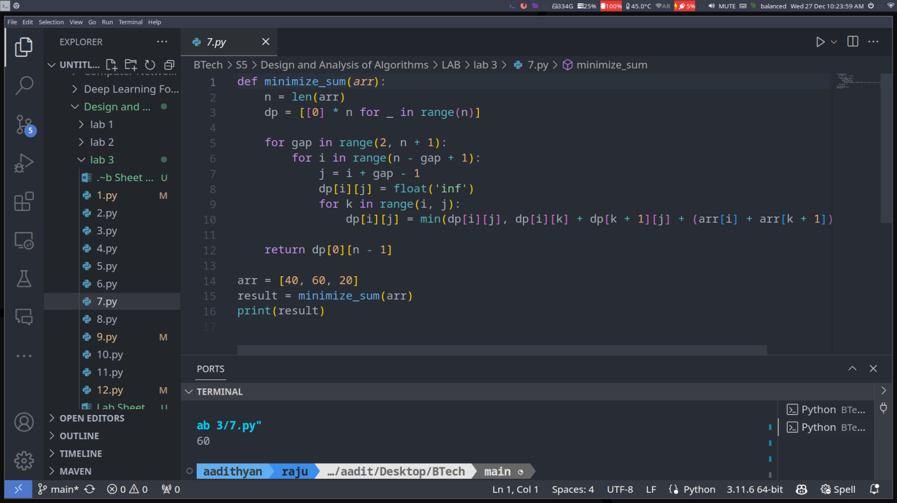

1. Given a sequence of matrices, find the most efficient way to multiply these matrices together. The problem is not actually to perform the multiplications, but merely to decide in which order to perform the multiplications.

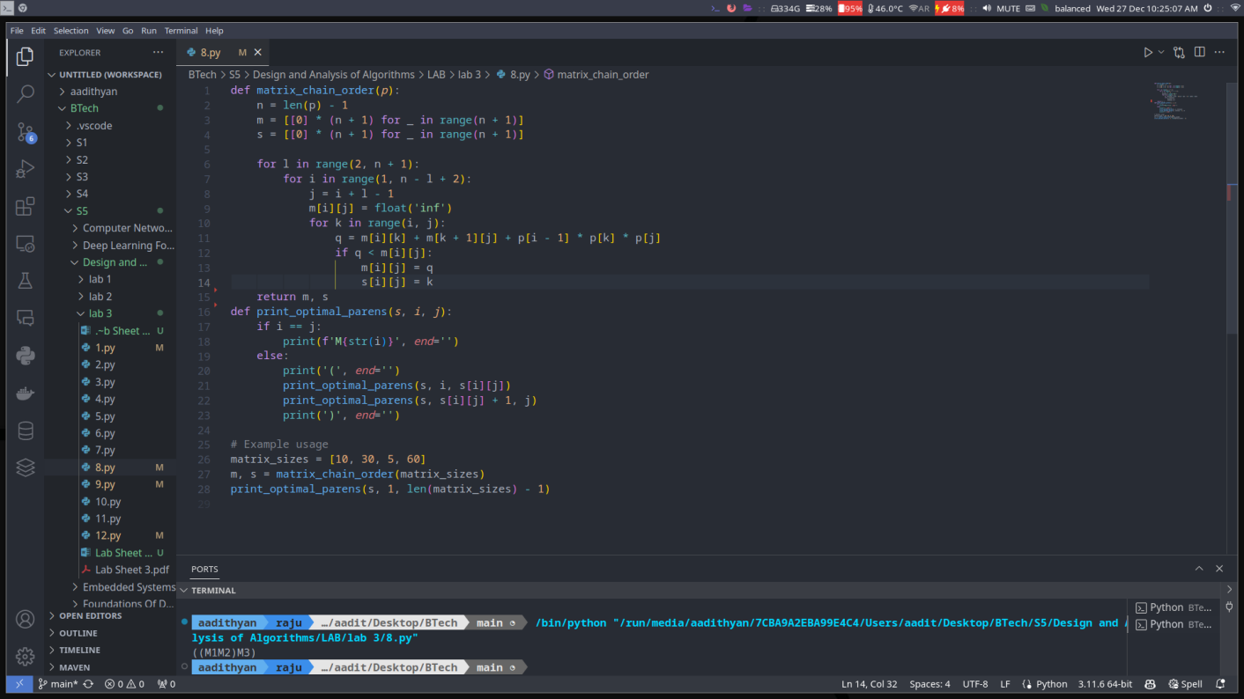

1. You are given a string ‘**str’**. Find the length of longest palindromic subsequence in the given string.

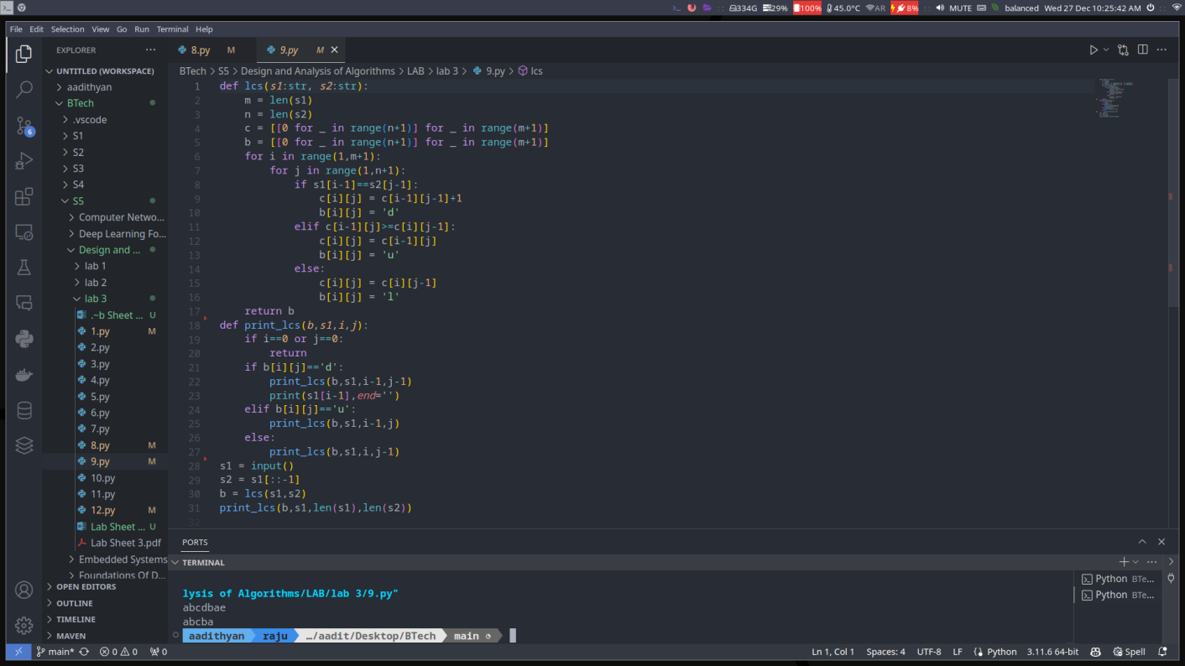

1. Given a sequence of n real numbers A(1) … A(n), determine a subsequence (not necessarily contiguous) of maximum length in which the values in the subsequence form a strictly increasing sequence.

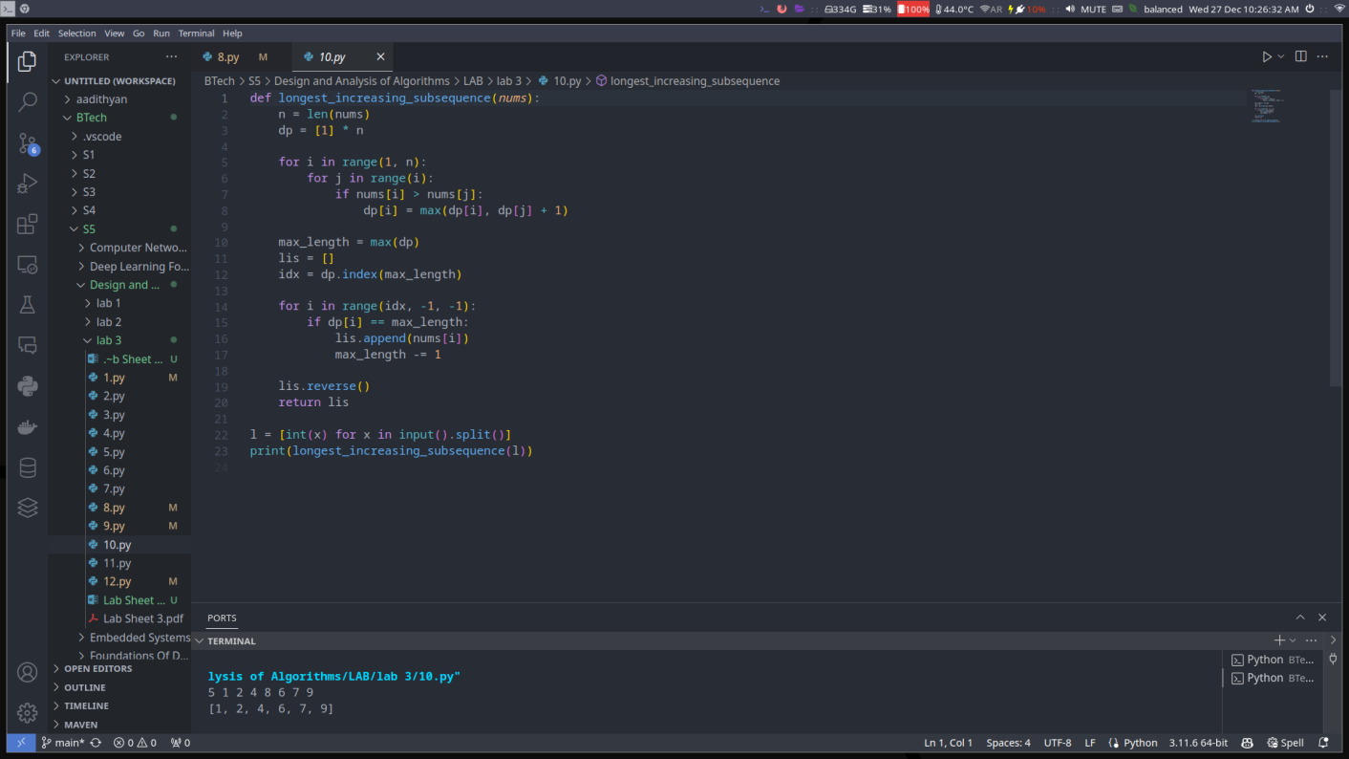

1. In a game, a player can score only 3, 5 or 10 points in a move. Given a score S, find the number of ways to reach the given score using the specified moves.

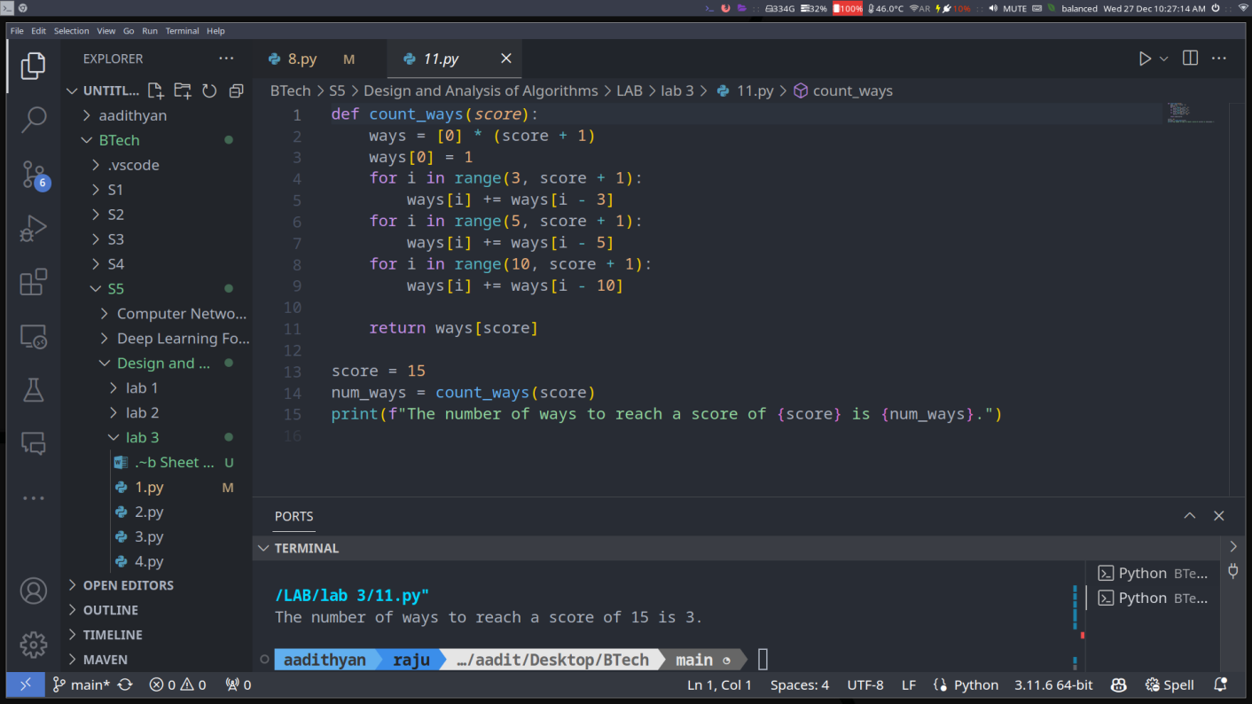

1. You are given a set of integers. Determine whether or not this set can be divided into two subsets such that the sum of elements in each subset is equal.

